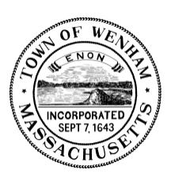

Town of Wenham

TOWN CLERK’S OFFICE

138 Main Street

Wenham, MA 01984

Ph: 978.468.5520 x1

Email: townclerk@wenhamma.gov

Kirsten Alexander, Town Clerk

Office | Term | Spots open
Town Moderator | 3 years | 1
Select Board | 3 years | 1
Assessors | 3 years | 1
Board of Health | 3 years | 1
Planning Board | 5 years | 1
Water Commissioner | 3 years | 1
Housing Authority | 5 years | 1
Housing Authority (fill term) | 4 years | 1
HW Library At-Large Trustee | 3 years | 2
HW Regional School Committee | 3 years | 2
HW Regional School Committee | 2 years | 1

2024 Annual Town Election Open Positions

Election Day is Thursday, April 11, 2024 7AM-8PM

Nomination papers must be returned to the Wenham Town Clerk’s office no later than 5:00 pm on Thursday, February 22, 2024. To get your name on the ballot, nomination papers must be certified with at least 21 signatures of Wenham voters (40 for School Committee). It is suggested you obtain at least 10-20 additional signatures in case a few are not able to be certified by the Town Clerk’s office. If you are interested running for a Wenham office for 2024 and have questions regarding the nomination/election process, please call the Town Clerk’s office at 978-468-5520 x1 or email townclerk@wenhamma.gov.

